AIS Design Olympiad - 2022
An Annual Event by AIS
For the next gen architects

Mumbai 11th February 2022 – Asahi India Glass Ltd (AIS) is India’s leading integrated glass and windows solutions company and a dominant player both in the automotive and the building & construction segments. Our product solutions spanning the entire breadth of automotive, building & construction, and consumer glass, are designed to deliver aesthetics and functional benefits.

The 3rd season of AIS Design Olympiad 21-22 Finale – National Event was conducted on 29th January 2022 on a Virtual Platform and the finalists (top two teams selected by the regional jury panel from each zone namely North, South, West, East and Central) presented their projects.
To develop and share best practices for deploying energy-efficient, cost-effective, comfortable infrastructure and responsibly reducing energy loads while improving thermal comfort, this year’s competition theme was “Adaptable & Sustainable Architecture for tomorrow” and the topics students could choose from and work on one were “Design for Better Workspaces” (A better & safer work environment for employees) Or “Rethinking Educational Institutions” (A healthier & safer educational institutes for the academic community).

The competition was judged by the eminent national Jury panel comprising of revered Jurors – Ar. Sonali Bhagwati (President at DPA, New Delhi), Mr. Mahesh Arumugam (Director at Meinhardt Façade Consultancy, Chennai), Ar. Raghuram (Director at CRN, Chennai), Ar. Karl Wadia (Sr. Architect at Hafeez Contractor, Mumbai), Ar. Paul Moses (Director at RSP, Bangalore) and Ar. Vivek Bhole (Principal Architect at Neo Modern Architects, Mumbai). Ar. Vivek Bhole was also the curator of the entire event.
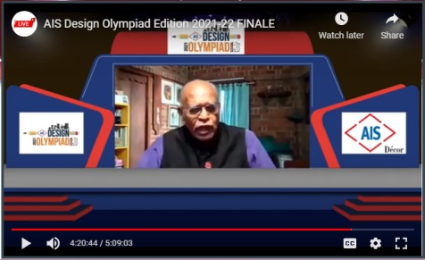
Mr. V.Suresh (Chairman of IGBC) graced the event as the chief guest and Mr. Jatin Shah (MD of Colliers India) was the Key Note Speaker.

The awardees were as follows:
Winners - Dr. Bhanuben Nanavati College of Architecture (Topic - Rethinking Educational institutions)
1st Runner up - IPS Academy, Indore (Topic - Design for Better Workplace)
2nd Runner up (There was a tie for the 2nd runner up position) - (1) Sir J.J. College Of Architecture, Mumbai (Topic - Design For Better Workplace) & (2) Marg Institute Of Design And Architecture, Tamil Nadu (Topic – Rethinking Educational institutions)
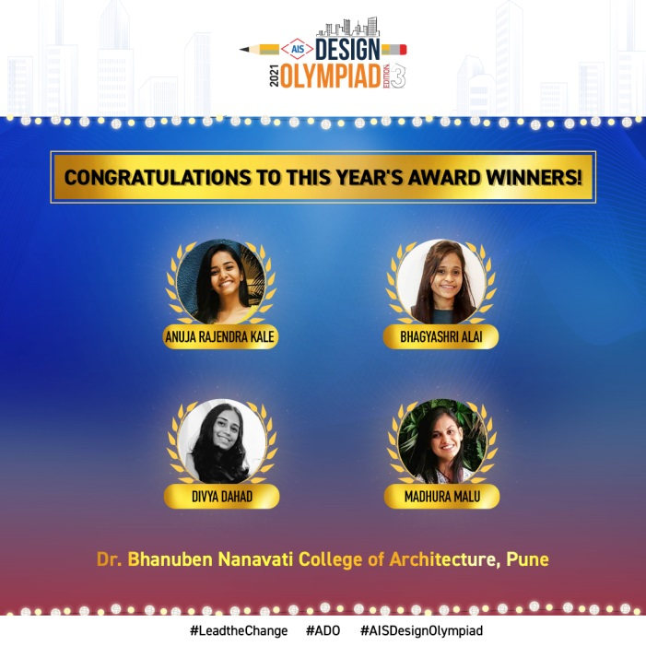
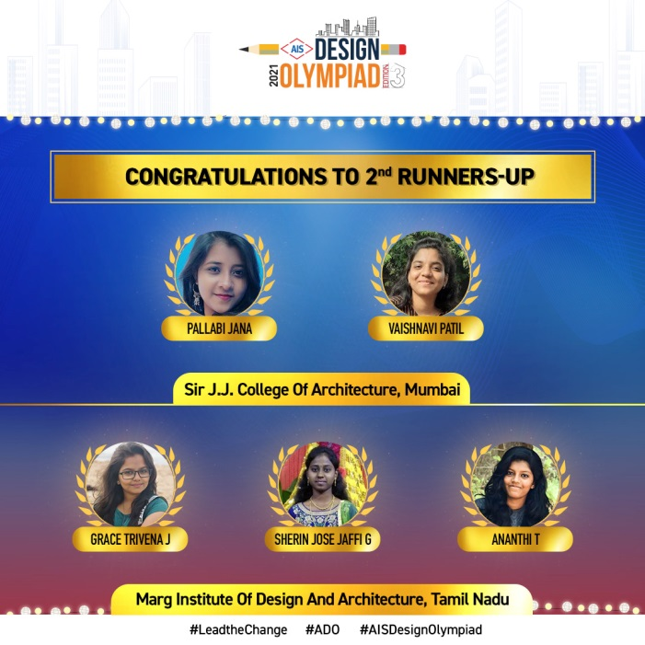
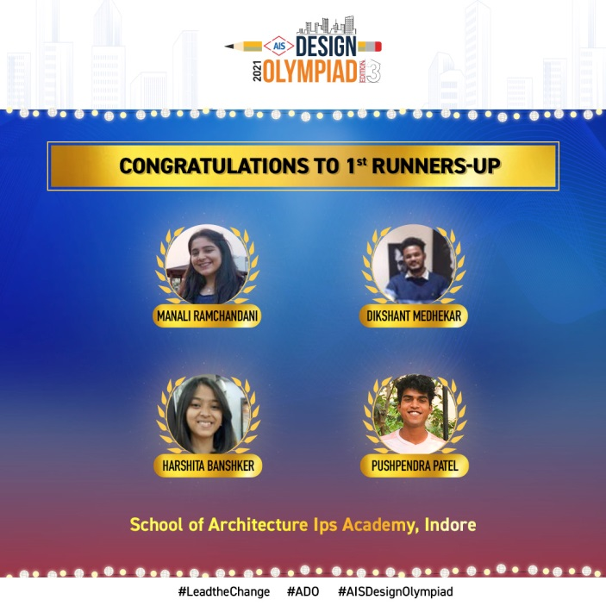

The winners received exciting cash prizes, certificates and trophies from AIS

Speaking at the occasion Mr. Vikram Khanna, COO (Architectural Institutional Business) & CMO – Asahi India Glass Ltd said, “It has been an honour and privilege for us to organize AIS Design Olympiad and have all revered Jury architects on the panel. The contest was curated with the purpose of providing a platform for the architecture students to use their capability & creativity in the projects and interact with the senior practicing architects in the industry. I sincerely thank all the honourable regional & national Juries, chief guests and keynote speaker for associating with us and imparting their wisdom to the budding architects throughout ADO 2022. I believe this event was a highly learning experience for all the participants, where they have been enriched with the knowledge.”

Ar. Vivek Bhole, Curator – ADO said, “Being on this platform helps not only students but us to learn many new-gen things from the students. The contest helped to bridge the gap between two generations of architects. It was great associating with AIS Design Olympiad as a Curator and Jury member again in its 3rd edition. I thoroughly enjoyed this journey with the AIS team and budding architects. His insights and career tips were an absolute delight to the students”

Mr. V. Suresh (Chairman of IGBC), who was Chief Guest at the ADO Finale said, “It was a pleasure to share the panel with the renowned jury architects. I congratulate AIS for holding this Olympiad, where they challenged students to think beyond the ordinary, helping them in bringing out the best of their talents on a national level platform and in front of industry stalwarts. It is important to practice sustainability to ensure energy-efficient, cost-effective, comfortable infrastructure and responsibly reducing energy loads while improving thermal comfort.”

Mr. Jatin Shah (MD of Colliers India), who was Key Note Speaker at the ADO Finale, said “I thank you for inviting me to be a part of the event and it’s been a real pleasure to sit through some of the presentations. It has not just been a great learning but a thoroughly engaging session to say the least. It is an absolute pleasure to see the young minds stretching their limits and putting together some thoughts that are already future ready. Indeed the future of the country is in the hands of really bright minds.”
---------------------------------------------------------- END---------------------------------------------------------------------
ABOUT AIS
AIS is India’s leading integrated glass and windows Solutions Company and a dominant player both in the automotive and the building & construction segments. Our product solutions spanning the entire breadth of automotive, building & construction, and consumer glass, are designed to deliver aesthetics and functional benefits. AIS today has 12 plants (including sub-assembly units), 8 offices, with a family of over 4,000 employees, spread across the country in strategic locations, supporting a discerning global and local customer base.

For more- https://www.aisglass.com

