Asahi India Glass Ltd. (AIS) Denotes Sustainability with

Mahindra TERI CoE (Centre of Excellence)

New Delhi, 18th June 2018: Mahindra and TERI’s new Center of Excellence (CoE) was inaugurated on 12th June 2018 in Gurugram by the group Chairman Mr.Anand Mahindra. Asahi India Glass Ltd. (AIS) – India’s leading integrated glass company has completed their most-celebrated energy efficient project Mahindra-TERI CoE’s new research facility.

Mahindra TERI Centre of Excellence for Sustainable Habitats has been established to develop energy efficient innovative solutions tailored to the Indian building sector and climates. It would also develop an effective dissemination strategy for energy efficient envelope design and water use for sustainable habitats. Mahindra TERI CoE is a SVA-GRIHA 5-star rated building. The recently inaugurated CoE at Gurugram has employed innovated products from AIS, India’s leading integrated glass company in its structure. Products like high performance energy efficient glass, uPVC doors and Windows, laminated skylight work & frameless doors were installed in this building.

On completion of the project, Sanjay Labroo, MD & CEO, Asahi India Glass Ltd (AIS) said “AIS has always believed in sustainable living and one of the ways to show our support and commitment to the same, is through our innovative, specialized and sustainable glass products and solutions. We are extremely proud to be associated with TERI and Mahindra group for this path-breaking project. I congratulate Mr. Anand Mahindra and Mahindra team, Dr Ajay Mathur and TERI team for selecting AIS as a partner of choice for glass solutions at the TERI Center of Excellence. At AIS we shall continue our efforts and investments to help create and support sustainable habitats."

Speaking at the launch, Mr Anand Mahindra, Chairman, Mahindra Group said, “We have used the planet’s resources disproportionately for our development so far. For India to develop, we will need to find new and innovative ways so as to reduce the adverse impact on our planet. To find the right balance between development and sustainability is a big opportunity for businesses to make profit and flourish and therefore being green should not be considered as a burden or cost.”
Talking about the need for green buildings and sustainability, Ms Anita Arjundas, Managing Director, Mahindra LifeSpaces said, “The Centre of Excellence is an outcome of the vision to bring academia, developers, and the building material industry partners together to work on building materials and innovation for the Indian context.”
Mr. Ajay Mathur, Director General, TERI said, “2/3rd of India is yet to be built. We need to find new sustainable building materials. This initiative of CoE has been 2 years in the making and has been made possible with Mahindra LifeSpaces and our partners like Asahi India Glass(AIS) who have supported the CoE with energy efficient fenestration and glazing solutions.”

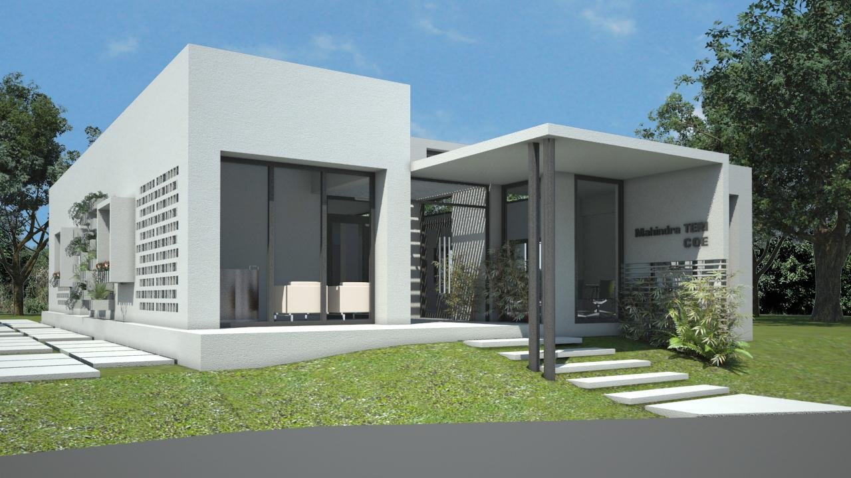

About AIS:

Asahi India Glass Ltd (AIS) is a dominant player across the architectural and automotive segments through its high performance fenestration and glass solutions. It has an established track record over the past three decades. Established in 1986, AIS’s footprint today spans the entire spectrum of the automotive glass value chains.
Company Website: www.aisglass.com

